The Foundation for Worldwide International Student Exchange

A NON-PROFIT STUDENT EXCHANGE PROGRAM
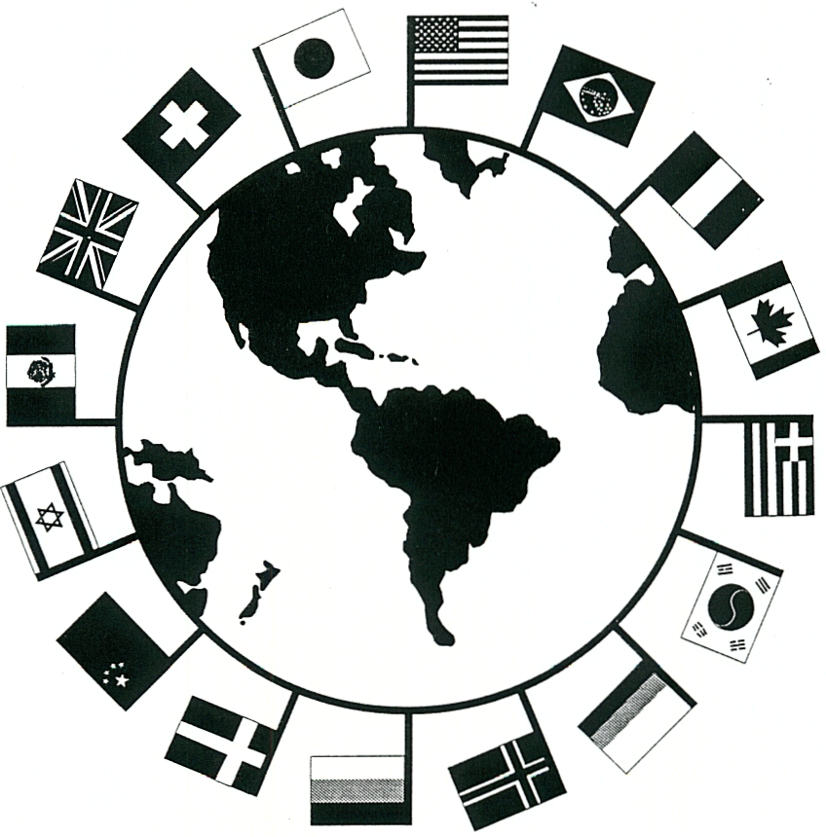

WISE Work & Travel Program Evaluation Form

Please take a few minutes to evaluate your experience with WISE. Your responses will enable us to improve our services to meet your needs and address any concerns that you may have.

- Fax the evaluation to 770 579 0219
- E-mail the evaluation back to worktravel@wisefoundation.com

As a participant on the WISE Work & Travel Program:
I would have liked more assistance with travel arrangements YES NO
I would have liked more assistance with orientation to my community YES NO
I felt the information provided about the DS-2019 was clear YES NO
I felt the information about the J-1 visa was clear YES NO
The information I received about insurance was clear YES NO
The information I received about the employer was clear YES NO

I would have liked more information on the following before arriving at my Work & Travel Site, please list and explain:

I feel that the Work & Travel Program Participant Manual was comprehensive YES NO
What can we do to make the Work & Travel Participant Manual better?

Please fully complete the following questions based upon your experience so far:
Did you read the WISE Work & Travel Participant Manual? YES NO
Would you recommend the Work & Travel program to friends? YES NO
Would you recommend your American employer to friends? YES NO
Do you have concerns that need to be discussed with WISE? YES NO

The most positive aspect of my program so far has been: (please give details of this experience)

The most negative aspect of my program so far has been: (please give details of this experience)

Please tell us about an aspect of the American culture that you have learned more about through your participation in this program:

Please tell us about an aspect of your culture that you have been able to share with your co-workers through your participation in this program:

Please tell us about three activities that you have participated in during your job that will be beneficial in meeting your future career objectives.

1.

2.

3.

Overall, are you satisfied with the program? YES NO

If NO, list any recommendations or suggestions you have that may improve the WISE program and delivery of service.

Name of Participant: Date:

****************************************************

